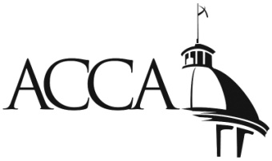
ASSOCIATION OF COUNTY COMMISSIONS OF ALABAMA
LIABILITY SELF-INSURANCE FUND, INC.
CLAIM FORM
USE THIS FORM FOR ALL LOSSES AND
INCIDENTS OTHER THAN AUTOMOBILE

Participant/County: | Date Reported:

Person completing form/Dept./Phone #:

Claimant name: | Claimant phone:

Address:

Any incident involving bodily injury should be telephoned to Meadowbrook Inc.
(1-800-536-7702 or 334-954-7200) immediately.

Please complete the questions below and on the reverse side of this form to the best of your knowledge and provide any estimates or other documentation available upon reporting.

Please give a description of the accident/incident:

Where did this accident/incident occur?

When did this accident/incident occur?

What property was damaged?

Please make sure you also complete the reverse side of this form.

COMPLETE THIS SECTION IF THERE
WERE ANY BODILY INJURIES

INJURED

Name: | Phone:

Address:

♦♦♦♦♦♦♦♦♦♦♦♦♦♦♦♦♦♦♦♦♦♦♦♦♦♦♦♦♦♦♦♦♦♦♦♦♦♦♦♦♦♦♦♦♦♦♦♦♦♦♦♦♦♦♦♦♦♦♦♦

Injuries:

Doctor or Hospital:

Forward any related documents and/or information that may be
helpful in resolving this situation to Meadowbrook, Inc.

Additional Comments:

WITNESSES:

1) Name: |  | 2) Name:
Address: |  | Address:
Phone #: |  | Phone #:
3) Name: |  | 4) Name:
Address: |  | Address:
Phone #: |  | Phone #:

Mail completed form to:
Meadowbrook Insurance Group
P.O. Box 11047
Montgomery, AL 36111

Or e-mail to:
mmacon@meadowbrook.com
with copy to:
ginger.conway@meadowbrook.com

